Lauren Mitchek, Mason Capers, and Faith Elrod
Caroline Jenkins
BAN 500-001
30 Nov 2025
Written Report
Superstore is facing a challenge with profitability despite the growing sales. The profit margin sits at 12.46% which is low. This indicates a level of operational inefficiency. Increasing the profitability of the company will only set the company up for long-term sustainability. As the analyst of this data, we looked at how to increase profitability and profit margin by implementing optimization strategies by relocating underperforming inventory categories. We analyzed what categories and sub-categories were lowering the overall profitability of the company as well as the regions that are underperforming, ultimately dragging the company’s metrics down.
The Superstore dataset looks at transactions across four years while taking into three product categories: Furniture, Office Supplies, and Technology. Those categories are broken down into subcategories. The data also looks at the four regions: West, East, South, and Central. Furthermore, discounts, profit, sales, etc. are incorporated into the dataset. We set forth to analyze regional profit comparison, categorical comparison to point out underperforming products, discounts vs profit correlation to emphasize when discounts harm the overall profit, and geographical influences on profit.
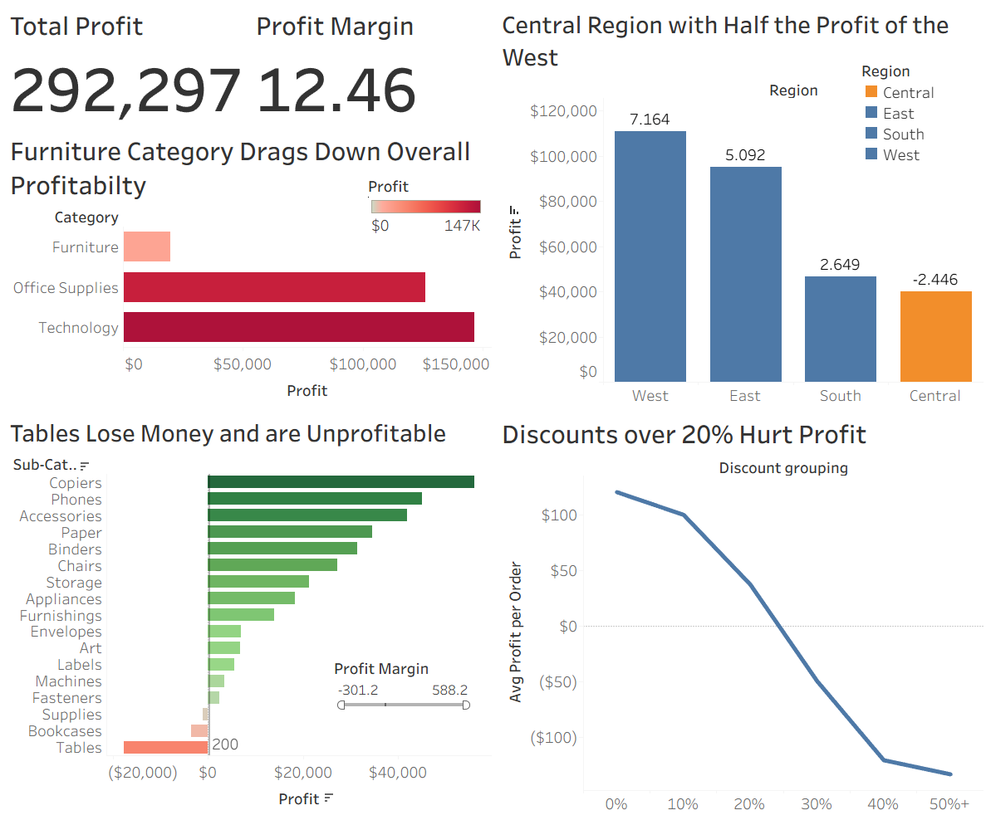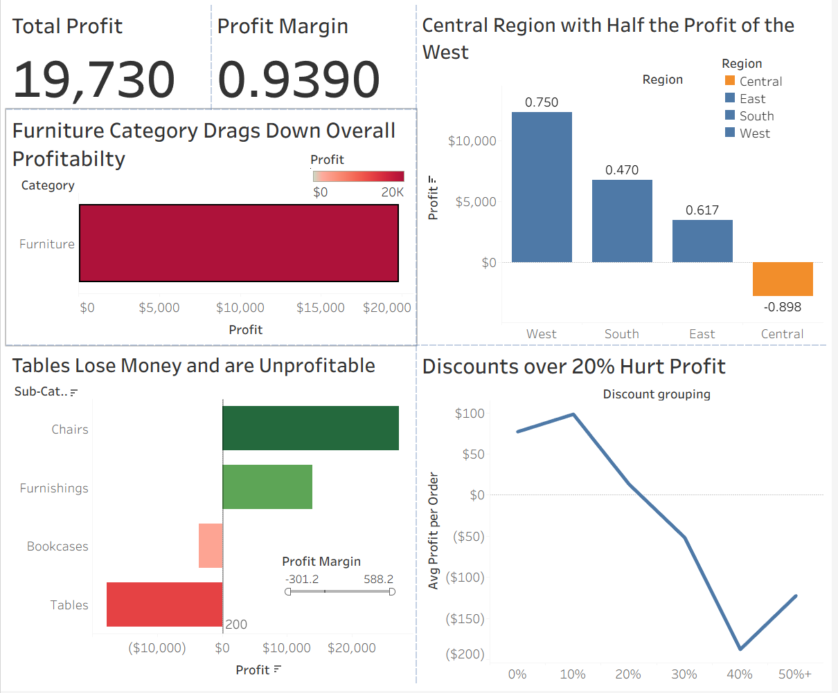
Figure 1 Figure 2
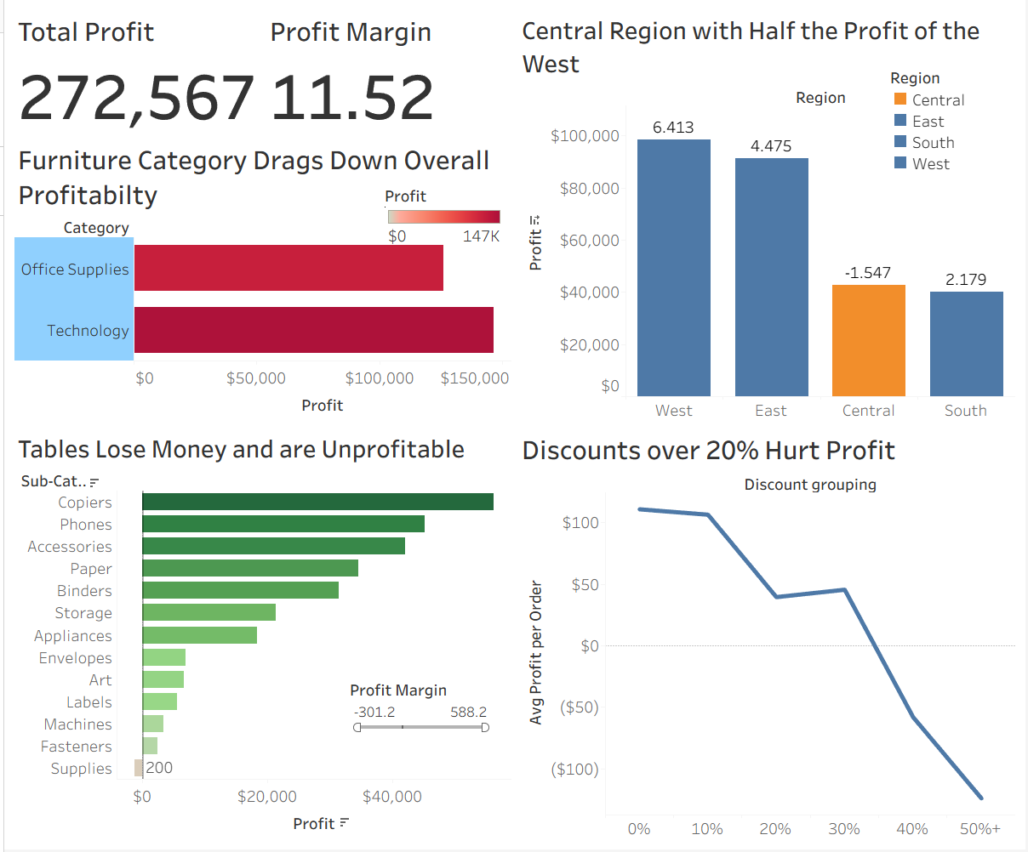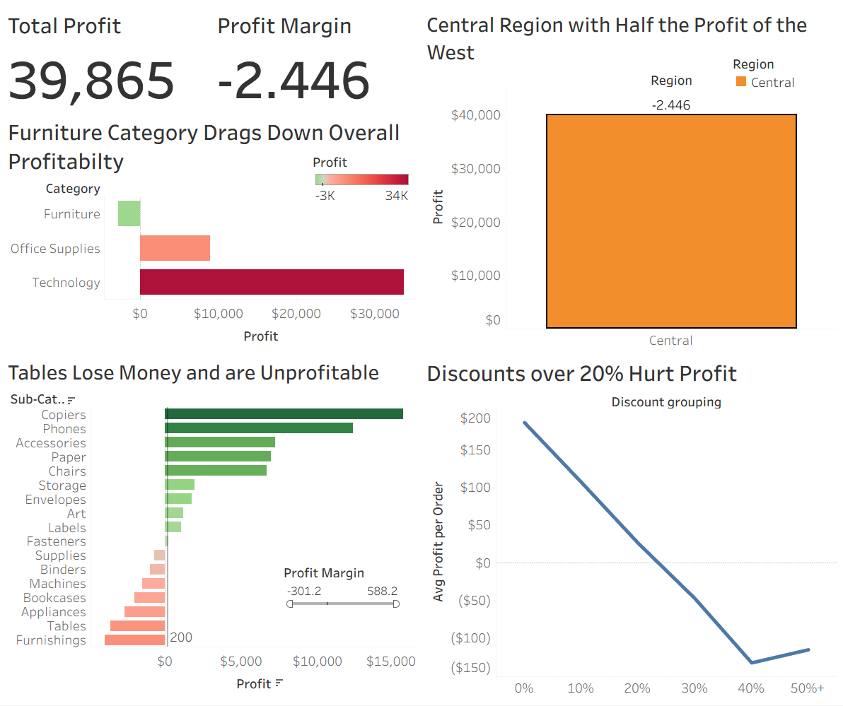
Figure 3 Figure 4
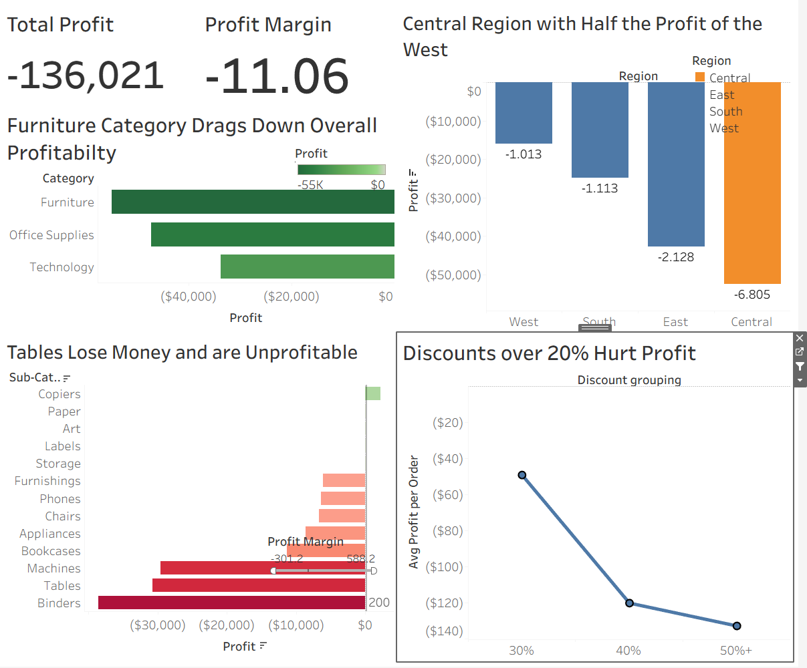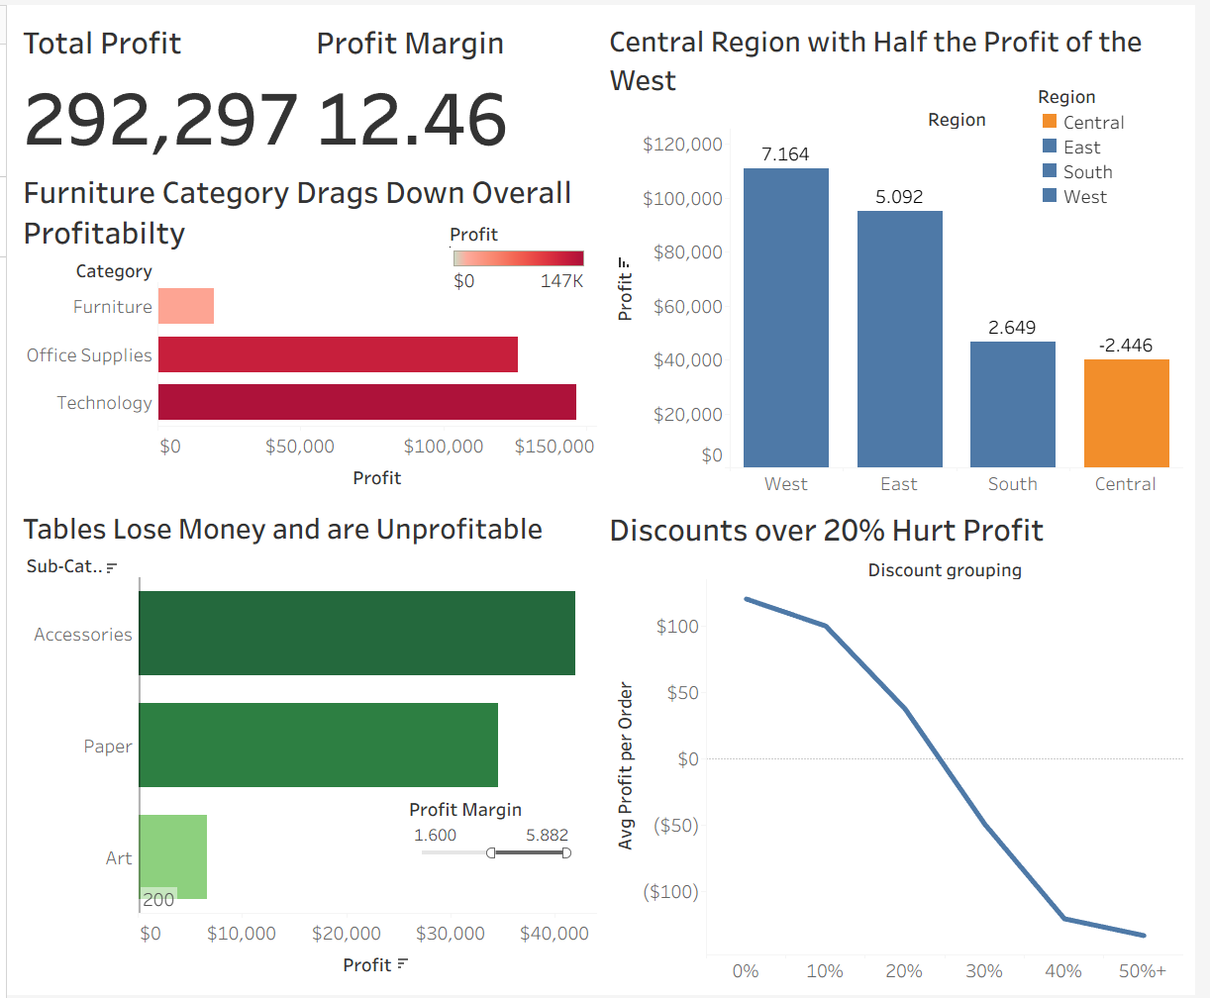
Figure 5 Figure 6
Furniture as a category provides a loss in profit margin and generates a loss in profit. As seen in Figure 1 there are three products that are in the red meaning a loss in profit as well as Furniture being the lowest profit made. When you filter for only furniture as seen in figure 2, you see a decrease in both Total Profit and Profit Margin. The losses outweigh the costs. In figure 3, you see how the other two categories are generating a high profitability. The key insights from the dashboard are that Tables, Bookcases, Supplies, and Fasteners are operating with little to no profit. Furniture is not a highly profitable category because of the Tables and Bookcases.
The Central Region also tends to be underperforming. As seen in Figure 1, the West region is double the size of the Central Region. As seen in Figure 3, if furniture was no longer a factor in the dataset, then the Central Region would actually be performing quite well. In Figure 4, we see that discounts heavily hurt the Central Region as well.
Discounting past 20% leads to a decrease in profitability. We see that profit is high with a 0% discount and is still relatively high after a 10% discount. 20% is still a positive profit but 30% and higher lead to a negative profit. As shown in Figure 5, total profit and profit margin are both highly negative when you only account for 30% and higher discounts. The only benefit from discounting items that low is if sales increase allowing for inventory to decrease from consumers buying the products.
Lastly, we see that in Figure 1, Copiers, Phones, and Accessories are our top performers. While that is important to note, the products with the highest profit margin are Accessories, Paper, and Art as seen in Figure 6. Paper is a consistent performer with a high profit margin which is a strong operating choice to keep as a product. Superstore can ultimately get rid of underperforming sub-categories but at the risk of losing customer convenience and sales.
In our data visualization, we applied Storytelling with Data principles to declutter and focus. We used minimal gridlines, no borders, and restrained use of color besides with a sole purpose. The absence of visual noise allows you to focus on what is truly important with our data. We also used color to highlight the Central region to emphasize the underperformance and green/red to highlight positive and negative performance. We made sure to title the graphs saying exactly what we want readers to take away.
We used horizontal and vertical bars to facilitate ranking naturally and make it natural to read. It led to easy comprehension of the data. We also used KPI cards to show metrics that are very important and we wanted to make sure the reader could always see. Lastly, we used a line chart to show the trends instead of a comparison.
Based on the analysis of the dataset, we recommend that we discontinue tables and try to breakeven with bookcases and furnishings. Also, change the discounts that are given. If discounts over 20% are causing a loss, then Superstore needs to avoid these at all costs. Next, compare the Central location to the West location and implement changes that work for the West region. We would also see an increase in the Central region with the restructuring of the Furniture category. Lastly, we recommend that Superstore expands inventory of the high performing products: Copiers, Phones, and Accessories.
We then took changes from our presentation to make our presentation and dashboard stronger. First, in Figure 7, you will see how we addressed the color. While we originally wanted to show profit being green, it ended up being too busy as a dashboard. Second, we addressed the $0 reference line. We made the line more prominent and bolder to be more visible. We wanted to highlight the fact that after 20% of a discount there was no profit being made, hurting our margins. Lastly, we changed the amount of space we took up in the dashboard. We wanted to add white space to allow for a decrease in the amount of cognitive load needed to comprehend our data. You will see in Figure 7 our new and updated dashboard to allow for the best comprehension of our data.
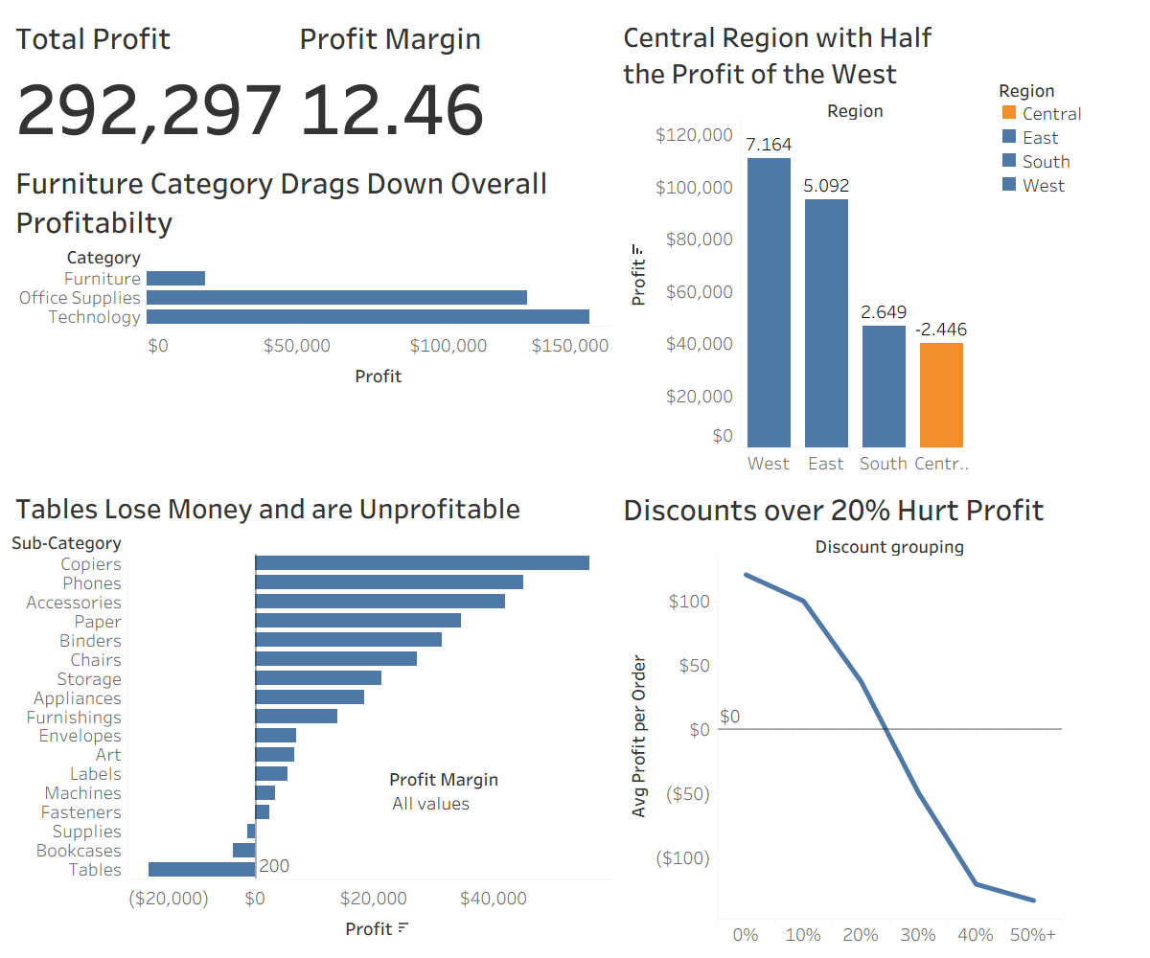
Figure 7
The next logical steps would be to cut discounts and start restructuring furniture. Next, they would start reviewing the West region and comparing it to the Central Region. Then, Superstore would deploy the practices from West to Central and start reallocating budget to increase inventory for high performance products. Lastly, make sure the furniture category is restructured and performing well.

